

KQC7016 DATA ANALYTICS
SEMESTER 2, 2025/2026

LAB 1 REPORT
Github Link:

Avienash A/L Shankar | U2103136/2
Sri Ganesh A/L Nithiyanathan | U2103177/2

Department of Electrical Engineering
Universiti Malaya

- Introduction
Web scraping is a technique used to automatically extract data from websites. The extracted data is usually in HTML format and is converted into a structured format for analysis. In this lab, Python libraries such as requests and BeautifulSoup are used to send HTTP requests, retrieve webpage content, and parse the HTML structure. The objective of this lab is to understand how web scraping works and to extract useful information from a website.

- Code with Explanation
import requests
from bs4 import BeautifulSoup

The requests library is used to send HTTP requests to the website. The BeautifulSoup library is used to parse and extract data from the HTML content.

URL = "https://books.toscrape.com/"
page = requests.get(URL)
print (page.text)

A request is sent to the website using the given URL. The server responds by returning the HTML content of the webpage.

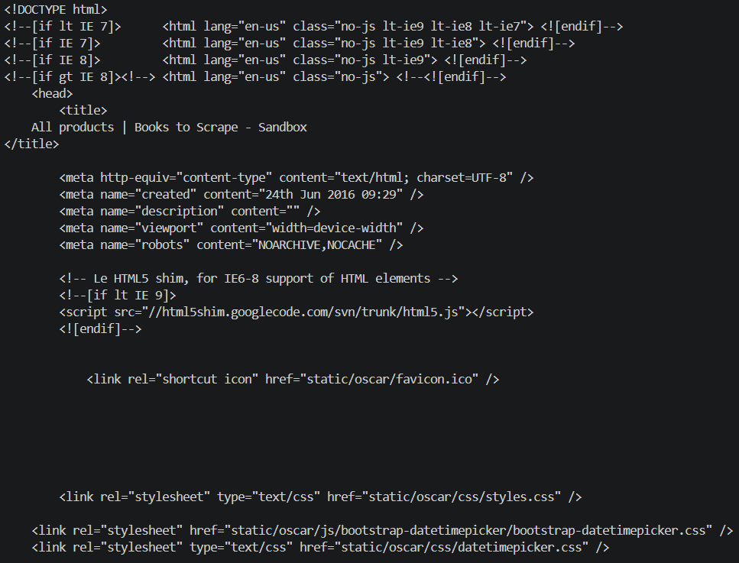
Figure 1: Output of page.text
soup = BeautifulSoup(page.content, "html.parser")

The HTML content is parsed using html.parser, allowing the program to navigate and search for specific elements in the webpage.

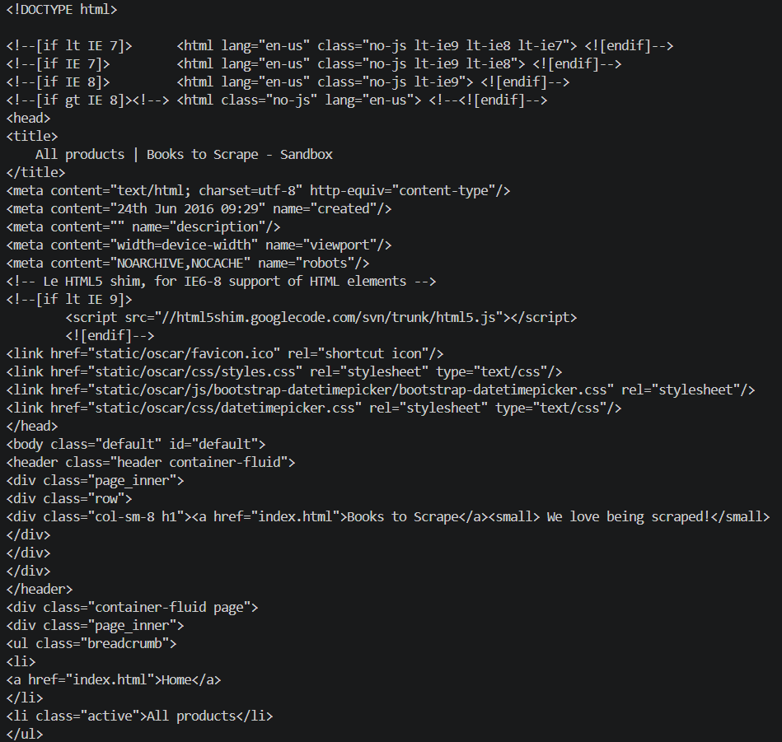
Figure 2: Output of soup

books = soup.find_all("article", class_="product_pod")

Each book on the webpage is stored inside an <article> tag with the class product_pod. The find_all() function retrieves all book elements.

for book in books:
title = book.h3.a["title"]
price = book.find("p", class_="price_color").text
print(title)
print(price)
print()
The title and price of each book are extracted. The title is stored inside the <a> tag, while the price is stored in a <p> tag with class price_color.

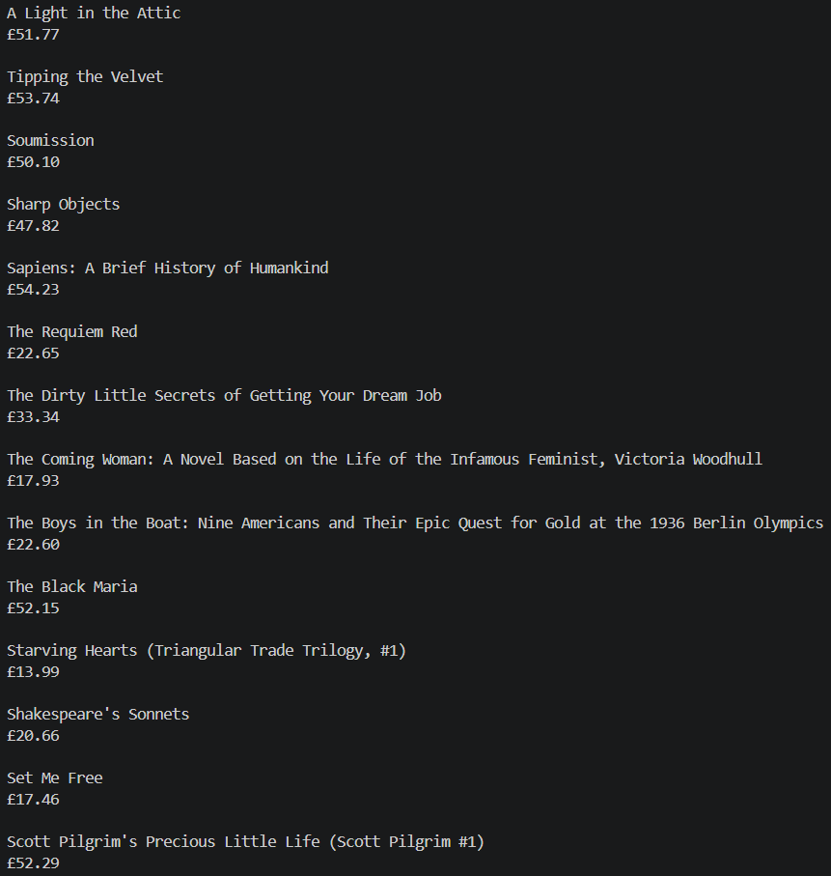
Figure 3: Final Output

# Additional Code
# Filter books under £30
print ("Books below £30:")
print()
for book in books:
price = book.find("p", class_="price_color").text
title = book.h3.a["title"]

price_value = float(price[1:]) #remove £ symbol

if price_value < 30:
print(title, "-", price)
print()

Additional Code: This code iterates through all the books extracted from the webpage. For each book, it retrieves the title and price, then removes the currency symbol and converts the price into a numeric value. A condition is applied to filter only books with a price lower than £30. If the condition is satisfied, the title and price of the book are displayed as output.
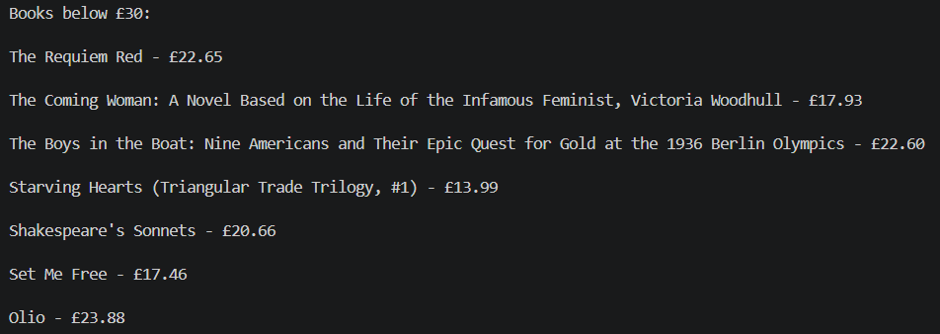
Figure 4: Output of Books below £30

- Results and Discussion
The code was successfully executed, and data from the website was extracted. The program retrieved book titles and their respective prices from the webpage. This demonstrates how structured data can be extracted from HTML using Python.
Initially, the provided code attempted to extract job-related data such as job title, company, and location. However, this structure did not match the selected website, resulting in errors. After modifying the code to match the correct HTML structure of the website, the extraction was successful.
One challenge faced during this lab was identifying the correct HTML tags and class names. This required inspecting the webpage using browser developer tools. Additionally, it is important to ensure that the website allows web scraping by checking its robots.txt file.

- Conclusion
In conclusion, this lab provided a clear understanding of web scraping using Python. The use of requests and BeautifulSoup enabled efficient retrieval and parsing of webpage data. The modification of the code highlighted the importance of understanding website structure before extracting data. Overall, this lab demonstrated the practical application of web scraping and its usefulness in data analytics.

